Simulation-Based Electromagnetic Analysis of TEM, TE and TM Propagation Modes in Microwave Transmission Structures

Aim
To simulate and analyze TEM, TE and TM propagation modes in microwave transmission structures, and to calculate the cutoff frequencies and propagation behavior of a rectangular waveguide operating at 10 GHz.

Procedure
- Open MATLAB and create a new script.
- Enter the operating frequency and waveguide dimensions from the input table.
- Convert GHz and millimetres to SI units (Hz and metres).
- Calculate the TE10 and TM11 cutoff frequencies.
- Compare each cutoff frequency with the operating frequency.
- Calculate the TE10 propagation constant and guide wavelength.
- Run the script and inspect the command-window results and field-pattern plots.

MATLAB Code

clc; clear; close all;
a=22.86e-3; b=10.16e-3; c=3e8; f=10e9;
x=linspace(0,a,150); y=linspace(0,b,100); [X,Y]=meshgrid(x,y); E=exp(-((X-a/2)/(a/4)).^2); H=E/377;
fc1=c/(2*a); fc2=c/2*sqrt((1/a)^2+(1/b)^2); k=2*pi*f/c; beta1=sqrt(k^2-(2*pi*fc1/c)^2);
x2=linspace(0,a,100); y2=linspace(0,b,100); [X2,Y2]=meshgrid(x2,y2); E1=sin(pi*X2/a); H1=abs(cos(pi*Y2/b)).^4; E2=sin(pi*X2/a).*sin(pi*Y2/b); H2=cos(pi*X2/a).*cos(pi*Y2/b); figure('Color','w');
subplot(2,4,1); contourf(X*1e3,Y*1e3,E,30,'LineColor','none'); colorbar; title('2D TEM Electric Field'); xlabel('X (mm)'); ylabel('Y (mm)');
subplot(2,4,2); contourf(X*1e3,Y*1e3,H,30,'LineColor','none'); colorbar; title('2D TEM Magnetic Field'); xlabel('X (mm)'); ylabel('Y (mm)');
subplot(2,4,3); contourf(X2*1e3,Y2*1e3,E1,20,'LineColor','none'); colorbar; title('TE10 E-field'); xlabel('x (mm)'); ylabel('y (mm)');
subplot(2,4,4); contourf(X2*1e3,Y2*1e3,H1,20,'LineColor','none'); colorbar; title('TE10 H-field'); xlabel('x (mm)'); ylabel('y (mm)');
subplot(2,4,5); contourf(X2*1e3,Y2*1e3,E2,20,'LineColor','none'); colorbar; title('TM11 E-field'); xlabel('x (mm)'); ylabel('y (mm)');
subplot(2,4,6); contourf(X2*1e3,Y2*1e3,abs(H2),20,'LineColor','none'); colorbar; title('TM11 H-field'); xlabel('x (mm)'); ylabel('y (mm)');
subplot(2,4,7); plot([1 2],[fc1 fc2]/1e9,'o-','LineWidth',2); set(gca,'XTick',[1 2],'XTickLabel',{'TE10','TM11'}); ylabel('GHz'); title('Cutoff Frequency'); grid on;
subplot(2,4,8); plot(1,beta1,'bo','MarkerSize',8,'LineWidth',2); xlim([0.5 2.5]); set(gca,'XTick',[1 2],'XTickLabel',{'TE10','TM11'}); ylabel('rad/m'); title('Propagation Constant'); grid on;
fprintf('TE10: fc=%.3f GHz, beta=%.2f rad/m\n',fc1/1e9,beta1); fprintf('TM11: fc=%.3f GHz; below cutoff at 10 GHz.\n',fc2/1e9); fprintf('TE10 propagates; TM11 does not.\n');

Expected Output
The MATLAB command window reports cutoff frequencies, the TE10 propagation constant, guide wavelength and waveguide length. Two contour plots show representative scalar transverse patterns: TE10 varies across the broad dimension, while the TM11 pattern varies in both transverse dimensions. These are illustrative scalar patterns, not full vector electromagnetic field solutions. At 10 GHz, TE10 propagates and TM11 is below cutoff.

OUTPUT/ GRAPH :
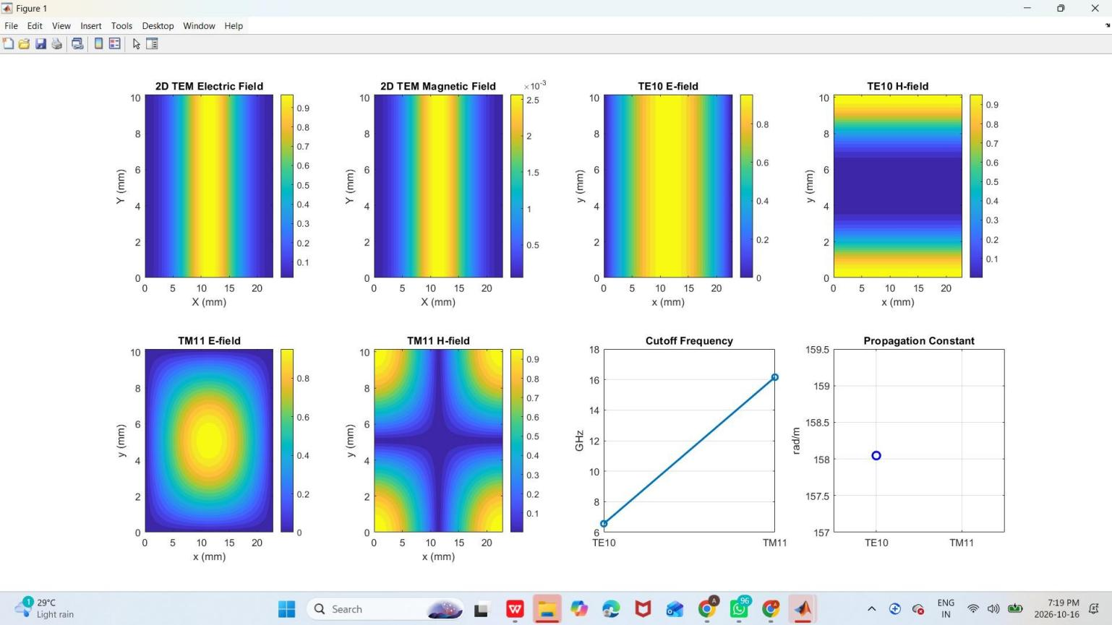

Calculations
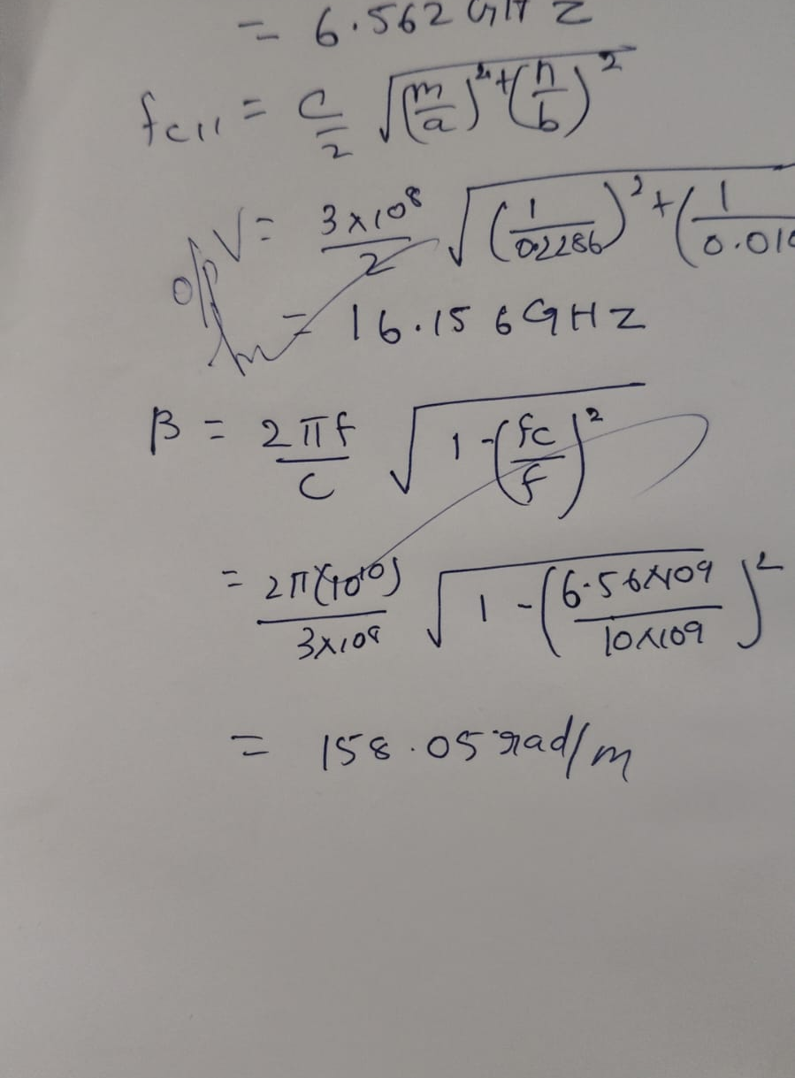

Results
For an air-filled WR-90 rectangular waveguide with a = 22.86 mm and b = 10.16 mm at 10 GHz, the TE10 cutoff frequency is approximately 6.562 GHz, so the dominant TE10 mode propagates. The TM11 cutoff frequency is approximately 16.42 GHz, so TM11 is below cutoff at 10 GHz. The TE10 propagation constant is approximately 158 rad/m and its guide wavelength is approximately 39.8 mm. A TEM mode cannot propagate in a hollow single-conductor rectangular waveguide. These results agree with the expected mode behavior under the stated ideal assumptions.

